Practical 9: Graph Traversal: Depth-First Search and Breadth-First Search
Practical Aim
To implement depth-first and breadth-first traversal on a graph and develop the ability to reason about how the order of exploration changes depending on the traversal strategy used.
Problem 1
A disaster relief team needs to inspect all buildings in a city after an earthquake. The city is mapped as a network where buildings are connected by roads. One team starts at a building and goes as deep into each road as possible before backtracking, while a second team spreads out level by level — first checking all buildings directly connected to the start, then all buildings two roads away, and so on. Given the city map as a graph and a starting building, implement both exploration strategies and print the order in which buildings are visited by each team.
Describe how the order of buildings visited differs between the two strategies on the same graph. What data structure does each strategy rely on to decide which building to visit next, and how does that structure cause the difference in order?
SOLUTION:
https://github.com/prathameshpandir-dev/DSA-Batch-B-SHP/tree/main/practical-9
OUTPUT:
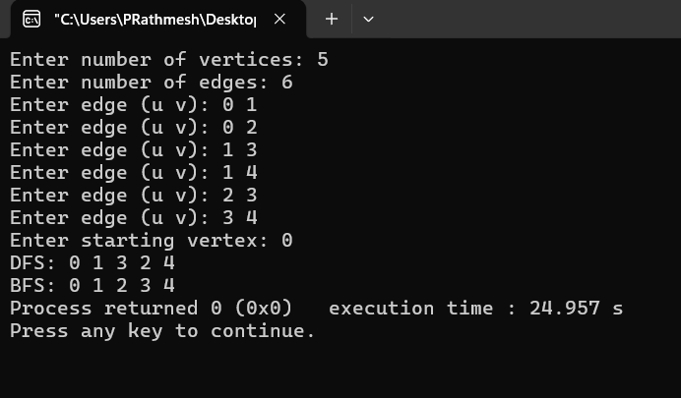

PROBLEM FACED:
The main difficulty was maintaining the visited array so that every reachable building is visited once. DFS uses recursion, while BFS uses a queue.
CONCLUSION:
DFS and BFS were successfully implemented. DFS explores deeply before backtracking, while BFS explores the graph level by level from the starting node.
Key questions
1. Problem 1
Answer: If the target building is very close to the starting building, BFS can find it sooner because it checks nearby levels first. If the target is very far and deep along one path, DFS may reach it sooner depending on the graph structure and the order of neighbors.
2. Problem 1
Answer: Recursive DFS can fail on a very large graph because the computer has a limited call stack. A large number of recursive calls can cause stack overflow. An iterative DFS using an explicit stack can avoid this problem.
Overall Conclusion
The practical successfully demonstrated DFS and BFS graph traversal. The difference between depth-first and level-by-level exploration and the role of recursion, stacks, queues, and visited tracking were understood.

